Crystals – Chemistry on the Atomic Level

Crystals are solid materials made up of a repetition of atoms or molecules. Crystals are identified by regular shapes and well-defined faces. Early scientists noticed that different mineral crystals had different shapes from each other, but that each crystal of a single mineral always had the same shape. These mineralogists determined that the shape of a crystal gave hints to its chemical composition.

The science of crystallography is the study and analysis of single crystals to determine their chemical compositions and the arrangements of atoms inside them. Crystallographers use X-Rays to “see” the atoms inside the crystal.

With a few crystals purchased from a rock shop, some regular table sugar and salt, and a microscope or magnifying glass to view the smaller crystals you can demonstrate several interesting features of crystals and explore Chemistry on the Atomic Level.

Items needed:

Crystal/geodes of Amethyst, Citrine and Quartz
Crystals of Calcite
Vials of table sugar (sucrose) and table salt (NaCl)
Microscopes or magnifying glasses for viewing crystals

Crystallographic and Mineralogical Terms

Crystal – a regular repetition of atoms or molecules forming a solid shape. Characterized by regular shapes.

Crystal System – the type of symmetry found in the repeating contents of the crystal. There are seven crystal systems used by crystallographers.

Morphology – the shape of an object

Amethyst, Citrine and Quartz

Look at the crystals of Amethyst, Citrine and Quartz. The amethyst and citrine clusters have many spear-like crystals sticking out of them. The shapes of these spears are the same, though they are different colors. They are also the same as the large quartz crystal.

Amethyst Citrine Quartz
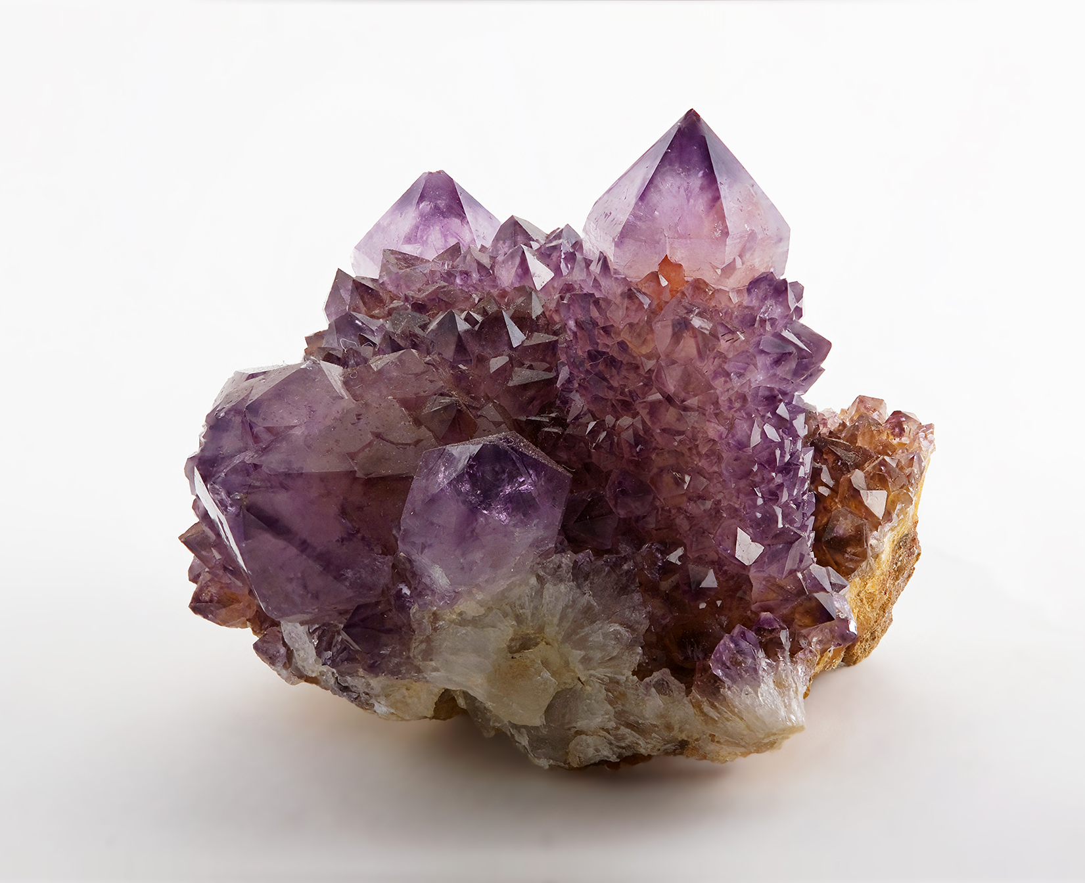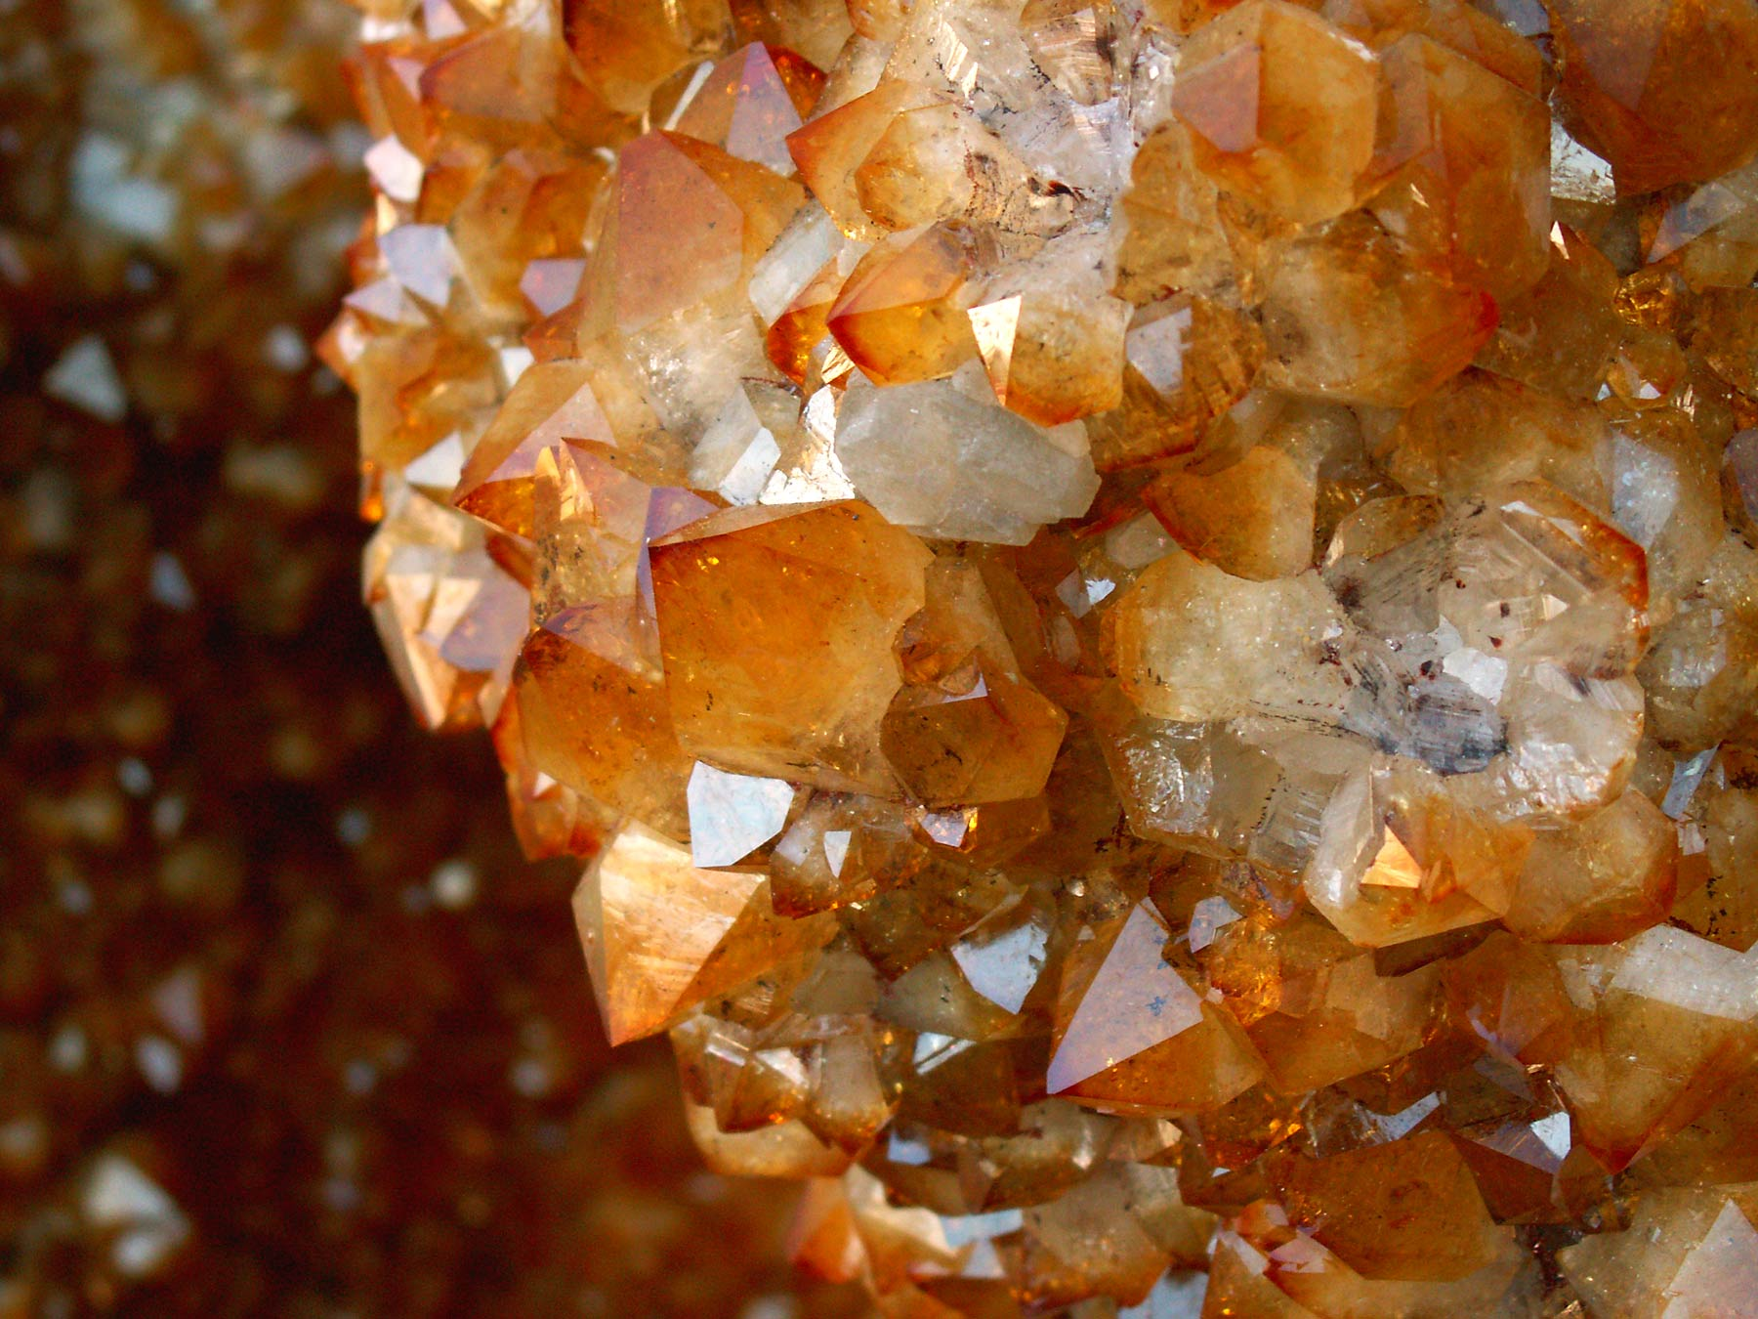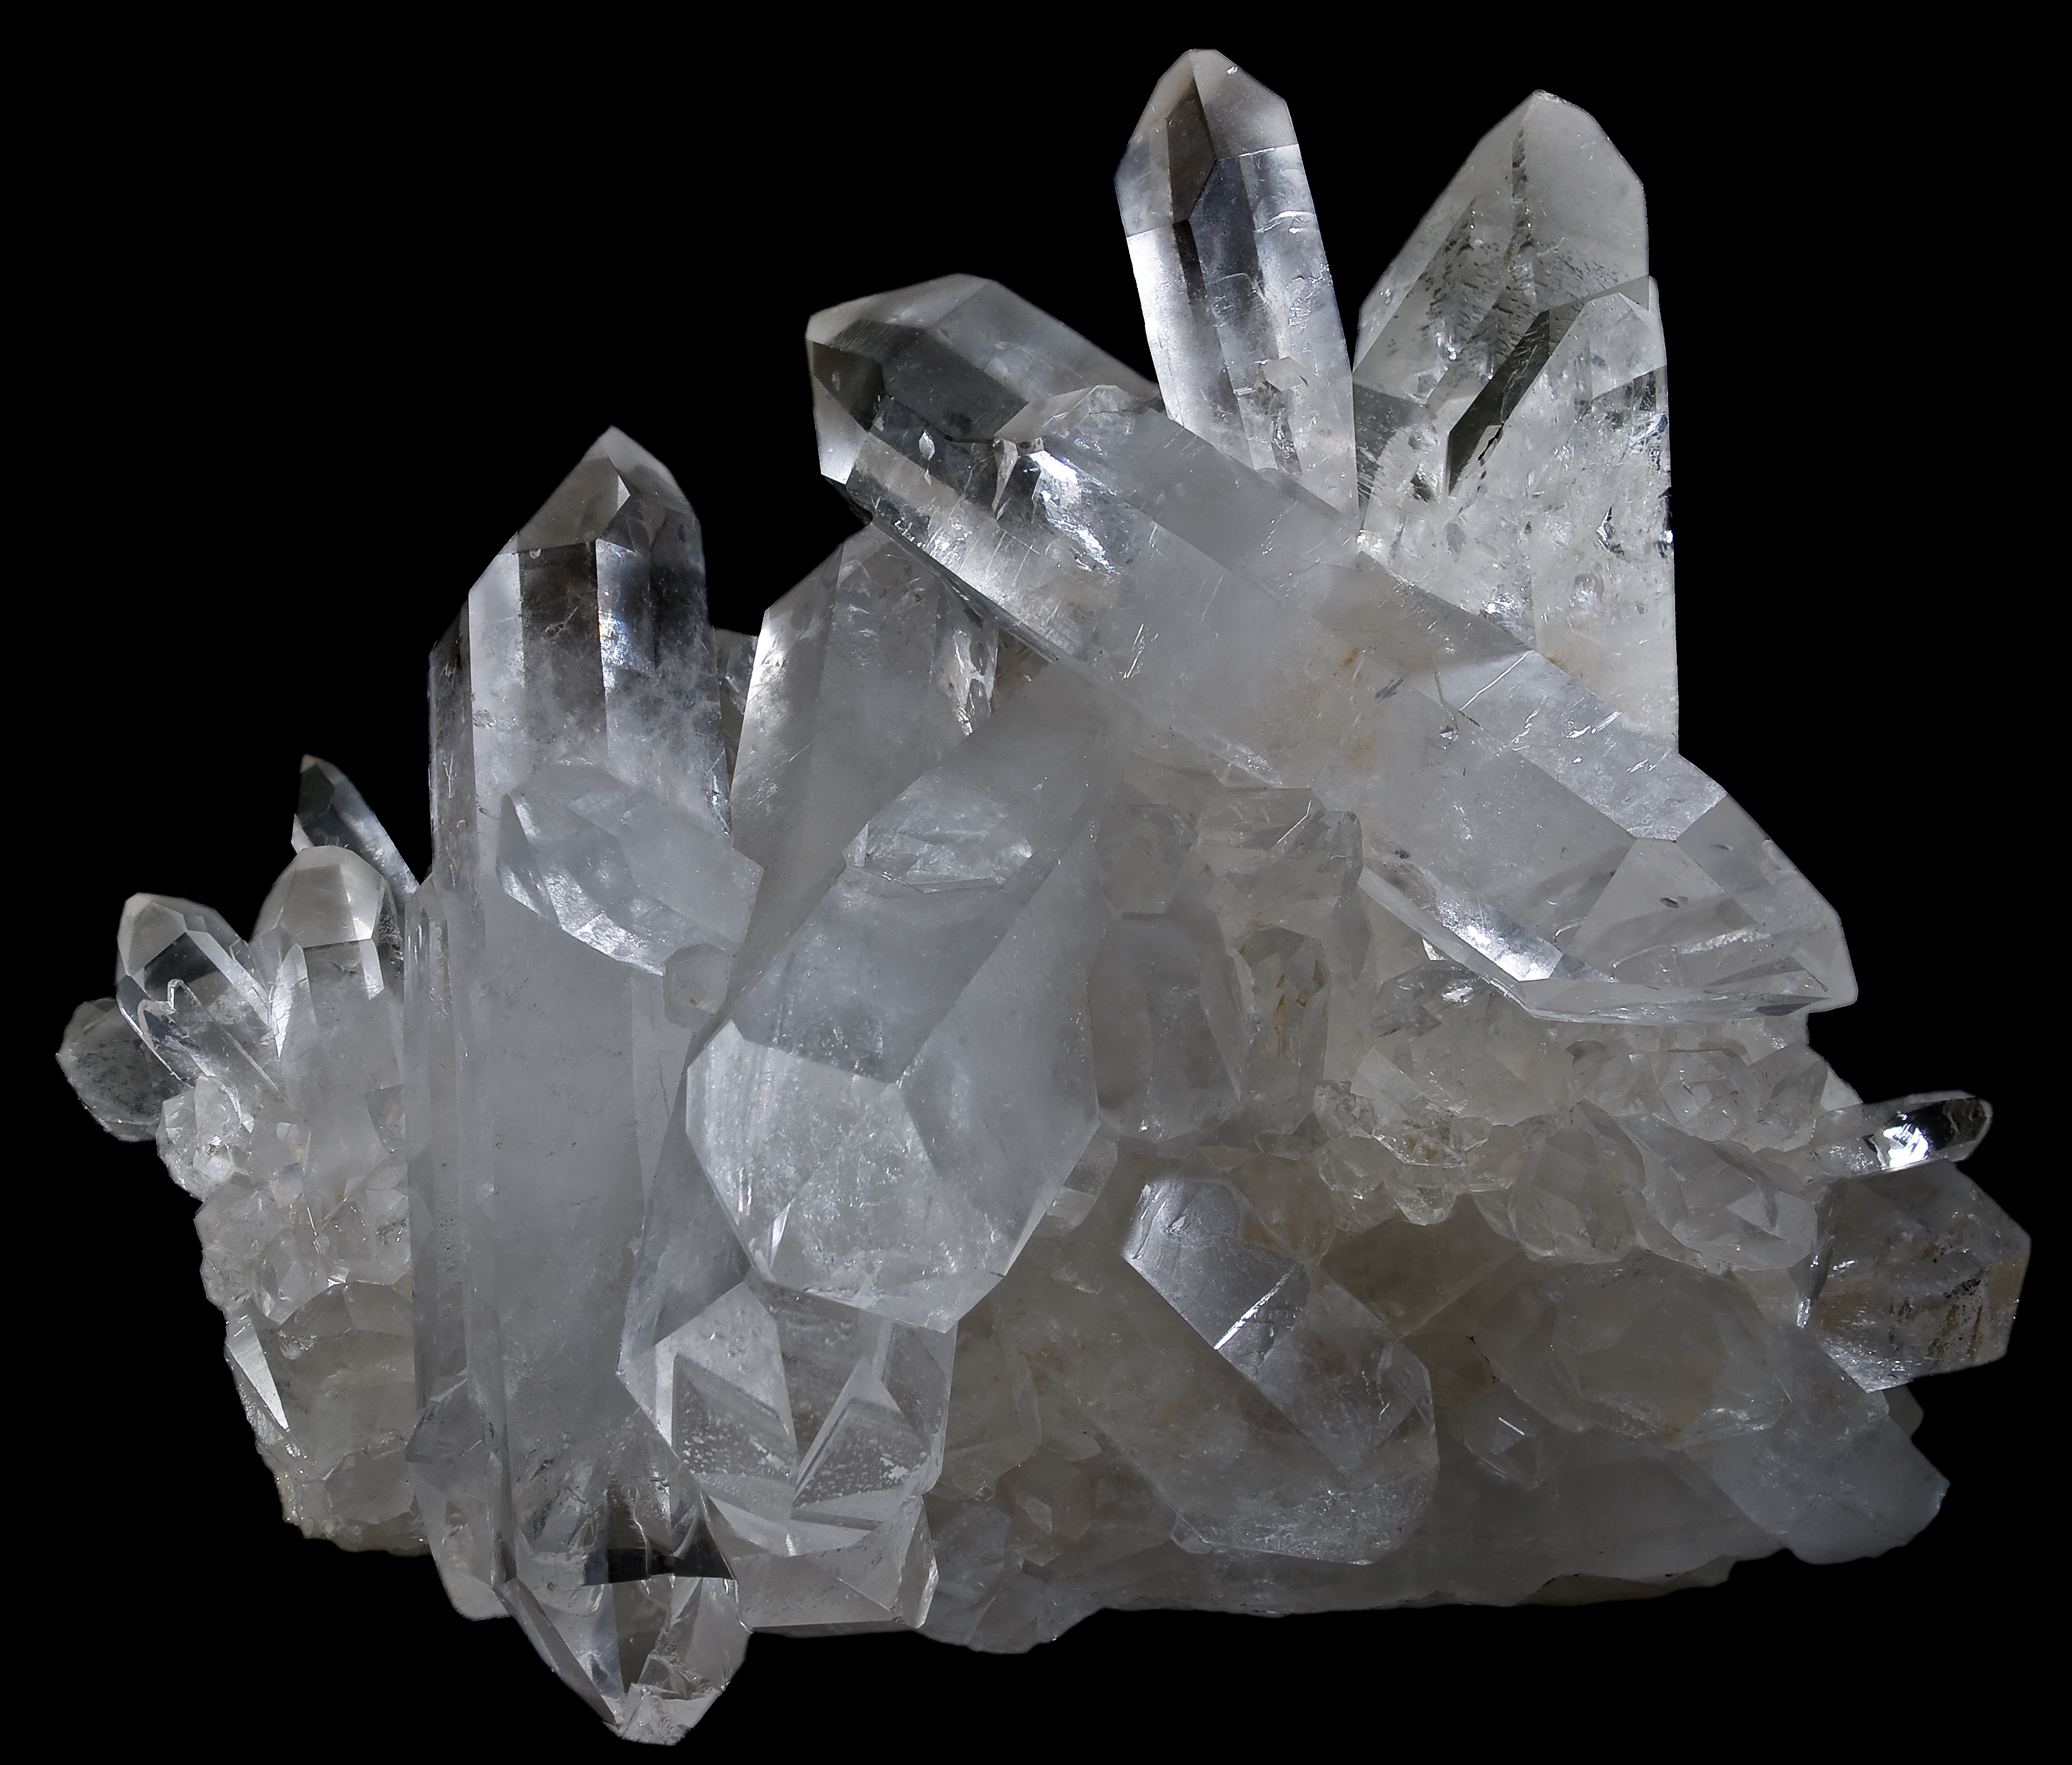

Why do you think they have the same shape (morphology)?

Why might they have different colors?

Discussion:

Crystals of quartz are formed by repeating silicon-oxygen tetrahedra (SiO₄). The resulting crystal structure is Trigonal and crystals have a six-sided column shape. Amethyst and citrine have the same Trigonal crystal structure, which is also formed by SiO₄ tetrahedra. Therefore, quartz, amethyst and citrine all have the same morphology.

The chemical formula of quartz, amethyst and citrine is SiO₂. Amethyst and citrine have impurities of iron in the crystal lattice which affects the color of the crystal.

Optical Calcite

Calcite is the mineral name of Calcium Carbonate (CaCO3). Calcite crystals show birefringence – or splitting one ray of light into two. All crystals except cubic crystals show birefringence. Look at the word “calcite” below through the Calcite crystal and see how the letters split. This is birefringence.

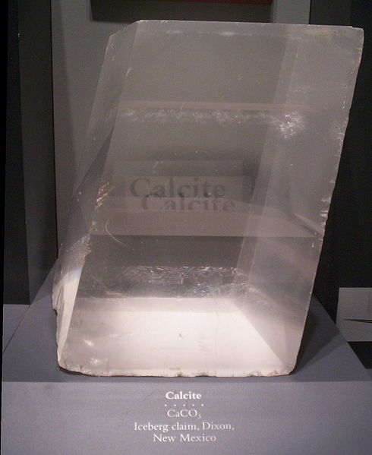

Sugar and Salt – Can you tell them apart?

Look at the two vials under the microscope. One of these vials is table salt (NaCl) and the other is table sugar or sucrose (C₁₂H₂₂O₁₁).

Can you describe the crystal shapes?

NaCl has cubic symmetry but Sucrose does not. Can you guess which vial is the salt and which is the sugar?

Discussion:

It would be easy to tell sugar from salt if you could do a simple taste-test. But in the chemistry lab, you never want to put a sample in your mouth! Perhaps, if we knew about the symmetry of the crystal structure of each compound, we might be able to tell the crystals apart, just by looking at them.

Sucrose has a Monoclinic crystal structure. The morphology of sucrose crystals matches the symmetry of the Monoclinic crystal system: the crystals are small rectangular prisms, with a slight tilt to them.

Salt (NaCl) has a Cubic crystal structure. Consequently, crystals of salt share this symmetry and resemble small cubes. When looking at these two samples under a microscope or with a magnifying glass, you can tell which is which just by looking at the shapes of the crystals.

